- Create a page aboutme.html that describes you.
Include information such as:
- Your name
- A description of you in <= 2 sentences. Emphasize important word(s) in bold.
- A list of courses you have registered this semester.
- Your 3 favorite movies, books, or TV shows, in order. Make at least one link to an interesting site about that TV show/movie/book.
- Two images that represent you when you're happy and sad.
- Something about one of your friends.

- Create a web page for a movie database
- Use lists to list out the movies of different languages (eg. English, Hindi, Tamil, Telugu, etc.)
- Use headings for movie titles.
- Use tables for listing top 10 or top 20 movies.
- Create web pages for movie reviews.
- Use links to navigate through movie reviews page.
- Use formatting tags to format the review page as well as the home page.

- Create a web page using for an online book store
- Divide the page into three frames.
- One of the frames should contain links to other web pages.
- Top frame should display the following details as a list.
  - Book Title
  - Author
  - Publisher
  - Edition
  - Genre
  - Price
- The Bottom frame should display an abstract or preface of what the book is all about

- Design FAQ page using CSS which displays ten questions. On clicking the question, answer should be displayed below it. (Hint: use display property)

- Design a web page using HTML and CSS for any theme in the following format. Use divisions and Box properties.

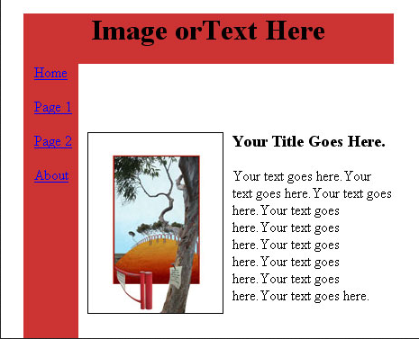

- Make a simple page with the following fields name, address, city, state, zip. Arrange things neatly in a borderless table so everything lines up and looks nice.

Name: | 
Address:
City:
State: | 
Zip:
Magazine:
Subscription: | 1 year 2 years
Additional Comments:


- Implement Image Slide show .

- Implement a Digital Clock in hh:mm:ss format

- Write a javascript to determine the age of a person if the date of birth is given as input.

- Design an Income Tax calculator using Javascript for the financial year 2014-15.

- Design a web page which takes username as input. Using cookies welcome the user if he visits the page again.

- Design a student registration form which takes student name, register number, DOB, program, email id, temporary address, permanent address, phone number.
Validate the following using javascript:
- Mobile number should be exactly 10 digits
- Register number should have alphabets and numbers only
- Name should not exceed 30 characters and can be only alphabets.
- Email validation
- Provide a checkbox saying “Permanent address is same as temporary address”. If checked, the value of permanent address should be added automatically from temp address. And should be in disabled mode.

